# **Algorithms**

## **Artificial Neural Network Classification**

Artificial neural network (ANN) classification is the process of learning to separate samples into different classes by finding common features between samples of known classes. It is an example of Supervised Learning. Known class labels help indicate whether the system is performing correctly or not. This information can be used to indicate the desired response, validate the accuracy of the system, or be used to help the system learn to behave correctly. The known class labels are a supervising learning process; the term is not meant to imply that you have some interventionist role. Also, it is generally presented as systems of interconnected "neurons" which exchange messages between each other. The connections have numeric weights that can be tuned based on experience, making neural nets adaptive to inputs and capable of learning. A multilayer perceptron (MLP) is a feedforward artificial neural network model that maps sets of input data onto a set of appropriate outputs with each layer fully connected to the next one. MLP utilizes a supervised learning technique called back-propagation for training the network. It seeks to classify an observation as belonging to some discrete class as a function of the inputs.

# **Implementation**

## **Software Tools**

In this project, Weka, Pandas, Keras, Tensorflow and Scikit-Learn are chosen to test data mining approaches as its character of containing a collection of visualization tools and algorithms for predictive modeling, which matches our aim to predicting mushroom based on analyzing results of training data.

Weka (Waikato Environment for Knowledge Analysis) is a popular suite of machine learning software written in Java, developed at the University of Waikato, New Zealand.

Pandas is an open source, a BSD-licensed library providing high-performance, easy-to-use data structures and data analysis tools for the Python programming language.

Keras is a high-level neural networks API, written in Python and capable of running on top of TensorFlow, CNTK, or Theano. It was developed with a focus on enabling fast experimentation. Being able to go from idea to result with the least possible delay is key to doing proper research.

TensorFlow is an open source software library for high-performance numerical computation. Its flexible architecture allows easy deployment of computation across a variety of platforms and from desktops to clusters of servers to mobile and edge devices.

Scikit-Learn is a Simple and efficient tool for data mining and data analysis. It Built on NumPy, SciPy, and matplotlib. Also, it is accessible to everybody and reusable in various contexts.

## **Attribute Transformation (For ANN Classification)**

In ANN Classification, the values of datasets must be a numerical value, and it has to be normalized to a numerical value between 0 and 1. Take training set and normalize numerical valued attribute to zero mean and unit standard deviation. For the test dataset, the same normalization is performed as to the training dataset using the same parameters calculated from the training datasets. Following python code is written to perform this data normalization.



## **Data Analysis (ANN Classification)**

To analyze data with artificial neural network method, we used Multilayer Perceptron method of classifier under functions folder. The results did not really change when the settings changed. In the results section, the results were derived from the settings of learning rate = 0.2, momentum = 0.2 and training time = 20.

## **Model Construction (ANN Classification)**

To solve this classification problem, a model of the dataset is needed. Models in Keras are defined as a sequence of layers. The first thing to get right is to ensure the input layer has the right number of inputs. This can be specified when creating the first layer with the input_dim argument and setting it to 13 for the 13 input variables as there are 13 columns in dataset needs to be inputted. Next, a fully-connected network structure with three layers is built for the model. Fully connected layers are defined using the Dense class. It specify the number of neurons in the layer as the first argument, the initialization method as the second argument as init and specify the activation function using the activation argument. After which, the rectifier (‘relu‘) activation function is used on the first two layers and the sigmoid function in the output layer. It used to be the case that sigmoid and tanh activation functions were preferred for all layers. These days, better performance is achieved using the rectifier activation function. We use a sigmoid on the output layer to ensure our network output is between 0 and 1 and easy to map to either a probability of class 1 or snap to a hard classification of either class with a default threshold of 0.5. Overall, the model have the first layer with 13 neurons and expects 13 input variables. The second hidden layer has 4 neurons and finally, the output layer has 1 neuron to predict the class (onset of top song or not). Following python code is written to build the classification model:



After the building the model, compile of the model is needed. Compiling the model uses the efficient numerical libraries under the covers which is TensorFlow. The backend automatically chooses the best way to represent the network for training and making predictions to run on your hardware, such as CPU or GPU or even distributed. When compiling, some additional properties are required when training the network such as “loss” function, “optimizer” function and “”metric” function. The “loss” function used to evaluate a set of weights, the “optimizer” used to search through different weights for the network and “metrics” used to collect and report during training. In this case, we will use logarithmic loss, which for a binary classification problem is defined in Keras as “binary_crossentropy“. We will also use the efficient gradient descent algorithm “adam” for no other reason that it is an efficient default. Finally, because it is a classification problem, we will collect and report the classification accuracy as the metric. Following python code is written to compile the model:



Up to now, the model structure is done and it is time to execute the model on the top song dataset. To train the model, calling the “fit()” function on the model. The training process will run for a fixed number of iterations through the dataset called epochs, that we must specify using the epochs argument. We can also set the number of instances that are evaluated before a weight update in the network is performed, called the batch size and set using the batch_size argument. For this project, the epochs is set to 5000 and batch_size is set to default. Following python code is written to train the model:



Lastly, the evaluation of the model needs to be done. This will give us an idea of how well we have modeled the dataset. After the evaluation, the accuracy rate of 93.67% is obtained. Following python code is written to evaluate the model:



Following image is the evaluation results of the model:



Additionally, Keras also allows to plot the learning curve and it shows the accuracy rate of the training process on the model. Following python code is written to plot the learning curve:



Following graph is the learning curve of the accuracy rate of the model:

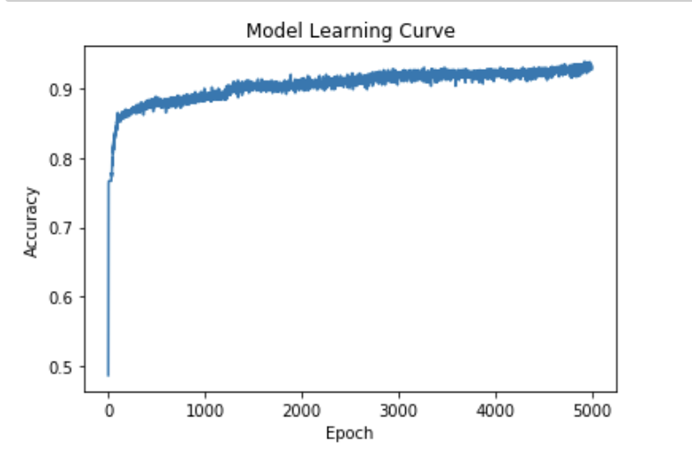

## **Results (ANN Classification)**

Now is time to predict whether a song will be a top song. First of all, the values in test dataset need to be normalized. After which, the class prediction will be used for the test dataset. A class prediction is given the finalized model and one or more data instances, predict the class for the data instances. Following python code is written to predict the class of the dataset (0: not a top song; 1: top song):



While predicting the classes of the songs, ANN Classification takes very short time to perform the classification. After the prediction, the following result is obtained:





Last but not least, besides the classification of the songs, the probability of song will be a top song also could be computed by ANN Classification. Following python code is written to predict the probability of a song that is a top song:



After the prediction, the following result is obtained:



# Analysis

## Confusion Matrix and Measurement for ANN Classification

|  |  |  |  |
| --- | --- | --- | --- |
| Predict Class | | | |
| Actual Class |  | Class = 1 | Class = 0 |
| Class = 1 | 127 | 13 |
| Class = 0 | 9 | 451 |
| Accuracy | 96.33% | | |
| Precision | 0.9338(Top=1); 0.972 (non-top=0) | | |
| Recall | 0.9071 (Top=1); 0.9804 (non-top=0) | | |
| Cost | 127*0 + 13*50 + 9*50 + 451*0 = 1100 | | |

From the result, there are 140 top songs and 460 non-top songs. However over these 140 top songs there are 13 song actually is not a top song. Also, in the of non-top songs list, there also have 9 songs never been mark out. Overall, result have 13 false positive and 9 false negative and the accuracy is 96.33 percentage. With this, we could conclude that Artificial Neural Networks is a flexible classifier to solve the non-linear dataset. As a component of an ANN fails, the net continues to operate. It performs very fast after training as well as gives a high accuracy rate.